

MINNESOTA VOIP INC. Voice & Data Specialists
9217 17th Ave. S. Bloomington, MN 55425 Tel: 612.355.7740 Fax: 952.888.6064

Telephone System Quick Reference Guide

HOW TO ANSWER A CALL

Simply LIFT the Handset and you will be connected to the ringing call.
To Answer Via Speakerphone PRESS the SPEAKER Key or PRESS the ANSWER Key on the Display

HOW TO MAKE AN INTERNAL CALL

Lift Handset…. Dial 3 Digit Extension Number

HOW TO MAKE AN EXTERNAL CALL

Lift Handset…..
Dial 10 Digit Telephone Number ( Must Include Area Code including 651)
For Long Distance calls it is not necessary to Dial a 1 before the Number

HOW TO PLACE A CALL ON HOLD

While in an active call, simply PRESS the HOLD Key… (found on your telephone display)
To return to the call PRESS the Flashing Line key….
or PRESS the RESUME Key (found on your telephone display)

HOW TO ANSWER A SECOND CALL RINGING AT YOUR TELEPHONE

To Answer a Second Call PRESS the Answer Key which will appear on the Lower Left corner of your telephone display. This will automatically put the first caller on hold. To return to the first caller,
PRESS End Call, PRESS Resume.

HOW TO TRANSFER A CALL TO ANOTHER EXTENSION

Answer the Call….. Press the Transfer Key…. ( found on telephone display)
Dial Extension Number…. ( wait for ring)
Press Transfer Key again.

Note: To announce the call before completing transfer, simply remain on the line until called party answers….
Announce the call…. Press Transfer to complete the call.

Page 1

HOW TO SET-UP A 3-WAY CONFERENCE CALL

Place or answer the first call….. PRESS the CONFRN Key…. (found on your telephone display)
Make the second Call (Internal or External )….
Wait for second party to answer…..
PRESS the CONFRN Key to join all parties.

HOW TO CALL FORWARD ALL CALLS

To Enable Call Forward Lift Handset and Dial *71
You will be prompted for the Redirection number…
Enter the telephone number you want calls forwarded to.

* To cancel Call Forwarding Lift handset and Dial *72

HOW TO ENABLE DO NOT DISTURB

Lift Handset and dial *78…..

Note: This will Re-direct all calls to your Voicemail……

To Cancel Do Not Disturb Lift Handset and Dial *79……
Call Pick UP

Lift handset Dial *87

COMMONLY USED VOICEMAIL FEATURES

HOW TO SET-UP YOUR PERSONAL VOICEMAIL

PRESS the MESSAGES button on your telephone…..
You will be prompted for your Access Code. ( all access codes are factory set at 0000 )
You will then be presented with the MAIN Menu of the mailbox…..

PRESS (1) To Hear your Messages
PRESS (2) To Change your Access Code
PRESS (3) To Record Your Name
PRESS (4 ) To Record a Personal Welcome Message
PRESS (5) To Record a Message for another Voicemail Subscriber
PRESS (9) To Select your Mailbox Greeting

HOW TO TRANSFER A CALLER TO VOICEMAIL

Answer the Call….. Press the Transfer Key…. ( found on telephone display)
Dial 8 plus the Extension Number…. Ex: 85501 ( transfer caller to mailbox 5501)
Press transfer to complete the transfer ….

Page 2

HOW TO RETRIEVE YOUR MESSAGES

From Your Desk:
PRESS the Messages button……
Enter your Access Code….
PRESS 1 to listen to Messages

From Outside the Office:
Dial your Personal 10 Digit telephone number…..
When your Personal greeting answers dial *
You will prompted for your Access Code….
Enter your Access code
Dial 1 to listen to messages

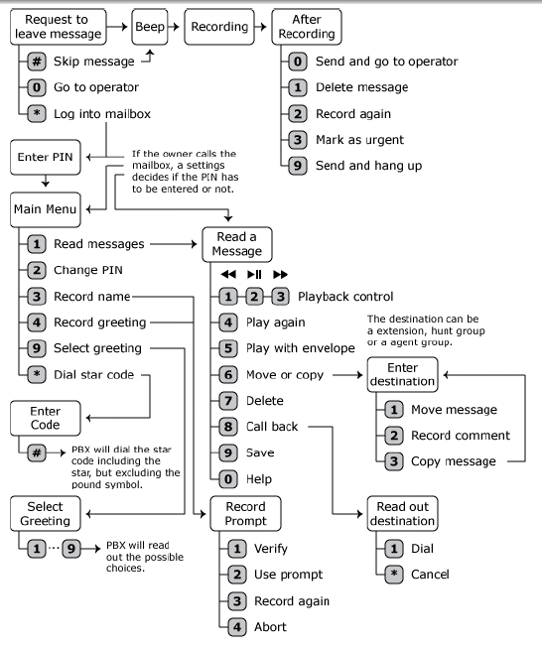
Page 3

